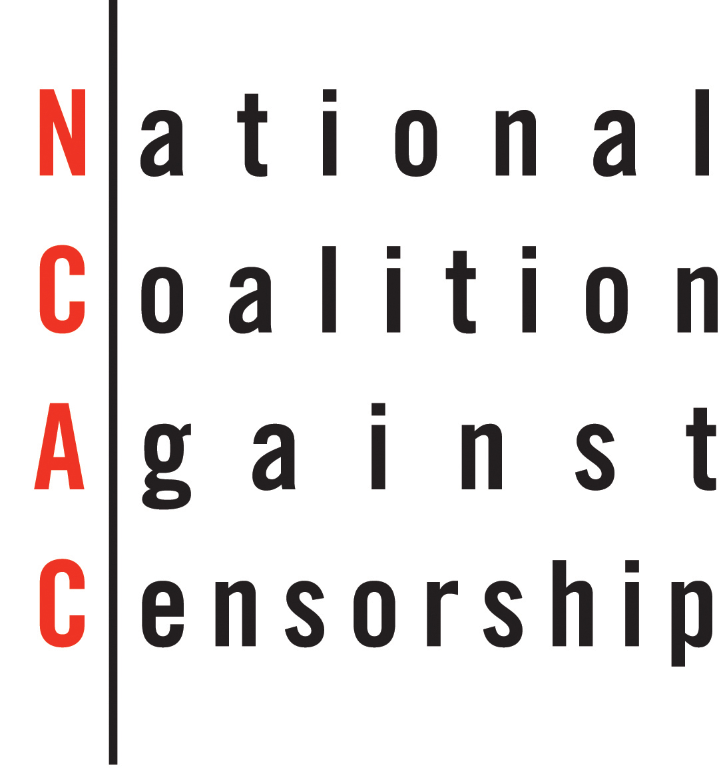

Annual Celebration of Free Speech & Its Defenders

FREE SPEECH MATTERS
Monday, November 6, 2017 <> Tribeca 360, New York City

Event Chairs

Barbara Marcus, President & Publisher, Random House Children’s Books

Ellie Berger, President, Trade Publishing, Scholastic Inc.

SPONSORSHIP OPPORTUNITIES

___Yes, please list me as a member of the Benefit Committee.

___ Obscenely Generous $25,000
- VIP seating for 10 guests
- Link to company website on NCAC website
- Gold journal ad to be appear online at ncac.org and on display at the event
- A feature article in Censorship News and NCAC’s website about your company’s position on censorship/philanthropic activities
- A program on censorship issues at your workplace by NCAC

___Profanely Generous $15,000
- Premiere seating for 10 guests
- Link to company website on NCAC website
- Silver journal ad to appear online at ncac.org and on display at the event.

___Indecently Generous $10,000
- Priority Seating for 8 guests
- Bronze journal ad to appear online at ncac.org and on display at the event.

___Offensively Generous $5,000
- Seating for 6 guests
- Ad to appear online at ncac.org and on display at the event.

E-Journal Ads:
___Gold Ad (includes gold border and display at event) $4,000
___Silver Ad (includes silver border and display at event) $2,500
___Bronze Ad (includes bronze border and display at event) $1,000
___Ad for Non-Profit Organizations (no border and display at event) $ 250

Please return no later than October 16, 2017. Earlier submissions receive more online recognition.
Camera-ready ad size (6 x 4” 300 dpi).

Tickets:
____ Premiere Seating $1,500
____ Priority Seating $ 500
____ Ticket $ 350
____ Non-Profit $ 200

Contributions:
___I/we cannot attend, but agree that Free Speech Matters and will contribute $__________in support of NCAC.

(Please turn over for table, advertising and ticket information)

Contact Information: Your Name (exactly as you would like it printed):

___________________________________________________________________________________________

Company Name (if applicable): _________________________________________________________________

Address:____________________________________________________________________________________

City, State, Zip:_______________________________________________________________________________

Daytime phone: _______________________________Email:__________________________________________

Payment Information: ___Check ____Credit Card ___www.NCAC.org ____Please Invoice

Checks payable & sent to: National Coalition Against Censorship, 19 Fulton Street, Suite 407, NY, NY 10038

Credit Card Payment: ___ Amex ___Visa ___ MasterCard

Card Number_________________________________________________________________________________

Exp. Date _______ Signature___________________________________________________________________

Address associated with card if different then above:_________________________________________________

___________________________________________________________________________________________

Visit www.NCAC.org/benefit for complete event information and easy online registration or submit this form.

The fair market value non-deductible portion of each dinner ticket is $150.
All other gifts are tax-deductible as allowed by law.

Information/Inquiries:
212.580-9228 ● FreeSpeechCelebration@gmail.com ● www.NCAC.org/benefit

National Coalition Against Censorship | 19 Fulton Street, Suite 407, New York, NY 10038

