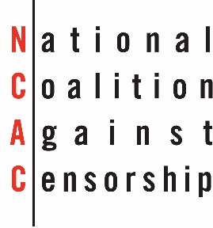
dddd
Christopher Finan
Executive Director

NCAC PARTICIPATING
ORGANIZATIONS
Actors’ Equity Association
American Association of
School Administrators
American Association of
University Professors
American Association of
University Women
American Booksellers for Free Expression
American Civil Liberties Union
American Ethical Union
American Federation of Teachers
American Jewish Committee
American Library Association
American Literary Translators Association
American Orthopsychiatric Association
American Society of Journalists & Authors
Americans United for Separation of
Church & State
Association of American Publishers
Authors Guild
Catholics for Choice
Children’s Literature Association
College Art Association
Comic Book Legal Defense Fund
The Creative Coalition
Directors Guild of America
The Dramatists Guild of America
Dramatists Legal Defense Fund
Educational Book & Media Association
First Amendment Lawyers Association
Free Speech Coalition
International Literacy Association
Lambda Legal
Modern Language Association
National Center for Science Education
National Communication Association
National Council for the Social Studies
National Council of the Churches
National Council of Jewish Women
National Council of Teachers of English
National Education Association
National Youth Rights Association
The Newspaper Guild/CWA
PEN American Center
People For the American Way
Planned Parenthood Federation
of America
Project Censored
SAG-AFTRA
Sexuality Information & Education Council of the U.S.
Society of Children’s Book Writers
& Illustrators
Student Press Law Center
Union for Reform Judaism
Union of Democratic Intellectuals
Unitarian Universalist Association
United Church of Christ
Office of Communication
United Methodist Church,
United Methodist Communications
Women’s American ORT
Woodhull Sexual Freedom Alliance
Writers Guild of America, East
Writers Guild of America, West
19 Fulton Street, Suite 407
New York, NY 10038
tel: (212) 807-6222
fax: (212) 807-6245
e-mail: ncac@ncac.org
web: www.ncac.org

To:

DRAFT – NOT FOR DISTRIBUTION

……. , 2018
Dear ,
The National Coalition Against Censorship (NCAC) and the undersigned organizations are extremely troubled by new policies and procedures aimed that block the release of artworks created by detainees held at Guantanamo Bay. In an abrupt change to practice, which enabled the public to see detainee artworks that had been reviewed and cleared for public release, these new policies amount to blanket censorship of materials that pose no threat to national security and possess clear historical and cultural value. We are especially alarmed by statements by government officials asserting that these materials are U.S. government property that can be confiscated, held indefinitely, and even destroyed.

This policy change was provoked by news of the art exhibition “Ode to the Sea” held at John Jay College of Criminal Justice in New York, in which displays artworks—predominantly watercolors of seascapes—by current and former detainees. Since all art that leaves Guantanamo is subject to intense scrutiny by military officials, the new directive serves no legitimate national security purpose. The only purpose it appears to serve is to block the public’s engagement with detainees’ artistic expression, hence removing an opportunity for discussion, curiosity or any uncomfortable empathy their artworks may inspire.

This baseless directive suppresses documents of historical importance, violating the American public’s right to have access to the full realities of their own government’s policies, as well as the human rights of the detainees under international norms. It uses art as a political football in an effort to prevent these works—and a deeper understanding of those who created them—from informing public discussion of the policies the US government makes in its citizens’ names.

NCAC and the undersigned vigorously assert the American public’s right to access to these artworks, to participate in a national conversation about the US government’s policies in Guantanamo so as to fully examine their government’s policies and their effects. We condemn this attempt to obstruct public discourse essential to a democratic and open society.

Sincerely,
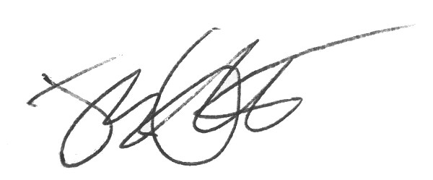
Joy Garnett
Arts Advocacy Program Associate
National Coalition Against Censorship

Cc:

