COMMONWEALTH OF KENTUCKY
FRANKLIN COUNTY CIRCUIT COURT
DIVISION: ______
20-CA-_____________

WENDELL BERRY and TANYA BERRY PLAINTIFFS

v.

UNIVERSITY OF KENTUCKY, ex rel.
ELI CAPILOUTO, PRESIDENT,
In his official capacity DEFENDANTS

COMPLAINT FOR DECLARATION OF RIGHTS
AND
INJUNCTIVE RELIEF
***** ***** *****

Introduction

This action seeks, first, a declaration that a mural painted in fresco by Ann Rice O’Hanlon (“O’Hanlon”) in 1934 at Memorial Hall on the campus of the University of Kentucky (“University”) as part of a Depression Era federal public works program funded with public money is the corpus of a charitable trust held by the University of Kentucky for the people of Kentucky to promote education, the arts, and governmental purposes.
Second, this action seeks injunctive relief that will prohibit Eli Capilouto, the President of the University, to forego any actions to remove or otherwise cause damage to either the O’Hanlon Mural or the piece titled Witness installed by the artist and non-party Karyn Olivier in 2018 as a companion to the Mural pursuant to a $30,000 commission of public funds by the University .

Parties

1. The Plaintiffs, Wendell Berry and Tanya Berry, husband and wife (collectively the “Berrys”), are citizens and residents of Port Royal, Henry County, Kentucky. Tanya Berry is a maternal niece of O’Hanlon, with whom she was very close, and is the oldest living heir of O’Hanlon.
2. The Defendant, the University of Kentucky (“University”), is a land grant institution of higher education founded in 1862 and exists by virtue of the laws of the United States and the Commonwealth of Kentucky. It is an agency of the central government of the Commonwealth. It is governed by a Board of Trustees. All property, real and personal, acquired by the University is held in the name of the Commonwealth of Kentucky for the use and benefit of the University, and so is publicly owned.
3. The Defendant, Eli Capilouto (“President”), is the president of the University of Kentucky by virtue of an appointment by the Board of Trustees and a written contract executed by the President and the Board on behalf of the University and the Commonwealth. At all times relevant herein, the President was acting within the course and stop of his powers and duties as an employee and agent of the University and the Commonwealth.
Jurisdiction and Venue
4. The Berrys seeks two remedies: a declaration of rights under KRS 418.040 that the O’Hanlon Mural, supra, is the corpus of a charitable trust and may not be removed from Memorial Hall; and, injunctive relief ordering the President from taking any action on his vague public announcement to remove or take down the O’Hanlon Mural and Olivier Installation, supra.
5. These actions are expressly vested in the subject matter jurisdiction of the Circuit Court.
6. The Franklin Circuit Court enjoys personal jurisdiction over the University and the President. The University is an agency of the central government of the Commonwealth whose capitol is Frankfort, Franklin County, Kentucky. The President is being sued in his official capacity as an agent and employee of the University.
7. Venue is proper in Franklin County Circuit Court.
Factual Allegations
8. In 1934, the federal government through Region 9 of the Public Works of Art Project (“PWAP”) commissioned Ann Rice O’Hanlon, a Kentucky native and alumna of the University of Kentucky, to execute a pubic work of art. The PWAP was a Depression era federal program designed to provide paying work for artists such as writers, photographers, and painters. Its success led to the more widely remembered Works Progress Administration’s Federal Arts Project that spanned 1936-1942, in which artists went on “relief” unlike the direct commissions of the PWAP.
9. The site selected by O’Hanlon, and approved by her supervisor Edward Rannells, was the entrance lobby of the then new, now iconic, Memorial Hall located on the campus of the University. It was completed and dedicated five years previously, in 1929, to honor the Commonwealth’s war dead in the First World War. All of the known names of those killed in action from Kentucky are inscribed on those walls, including African-Americans.
10. The commission was executed as a fresco which was unusual in the United States at that time. Of the over 15,000 works commissioned by the PWAP across the country between 1933–1935, only 42 were frescoes.
11. The technique of fresco is a remarkably difficult one to execute. It requires significant training and craftsmanship married to an accomplished artistic ethos. It entails painting on damp lime plaster prepared within hours of that day’s painting. The application of the paint demands exacting improvisation since the pigments cannot be corrected once applied. The entire process creating the fresco took approximately eight months for O’Hanlon to complete.
12. The choice by O’Hanlon to execute her mural in fresco was influenced by the triumvirate of great Mexican muralists of the early Twentieth Century, including Diego Rivera, who had reintroduced the use of large scale frescoes in mural making. O’Hanlon’s husband, Richard, had apprenticed and studied under Rivera. Richard O’Hanlon served as O’Hanlon’s assistant on the Memorial Hall mural, preparing daily the necessary wet lime plaster on which she painted.
13. O’Hanlon settled on a mural depicting the history of Lexington and central Kentucky. The administrators of the PWAP focused on the “American Scene” so that this subject matter choice was well within that scope. During the project, O’Hanlon reported that the only persons interested in her, the nature/purpose of the work, and the processes of the work were African-Americans working at the University who would visit her at night bringing her apples, Coca-Colas, and keeping her spirits up during the tedium of the actual work and spend breaks to watch her work. O’Hanlon reports regularly engaging in conversation about the work, asking and answering questions, which she observed stood in stark contrast to any interest of the staff and faculty at UK or the white citizens of Lexington who basically ignored the project.
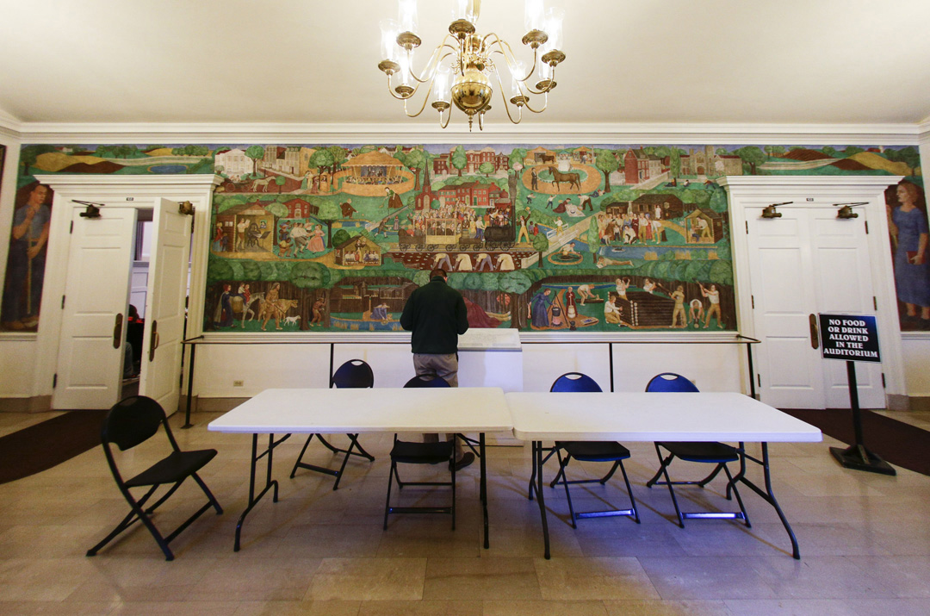
14. The O’Hanlon Mural is a figurative representation of the history of Lexington and Central Kentucky from Bryan’s Station to contemporary times circa mid-1920s where O’Hanlon sought to portray a “Chatauqua”. It is “read,” left to right frieze style in four main “blocks,” and framed by allegorical images of two large scale figures, a man and woman. The central “frame” is a device termed the “golden section”. O’Hanlon, similar to Rivera, deployed natural forms somewhat primitive in nature. These are artistic choices that abstract the essential truths of the art as opposed to mere representation. It is part of what makes the O’Hanlon Mural unique and a valuable piece of the cultural treasure of Kentucky held in trust by the University.
O’Hanlon Mural ca. 2015
15. The completed O’Hanlon Mural is an actual part of the building itself. The plaster is an inherent part of the lobby walls on which it is painted. The completed Mural leaves brilliant, nearly indestructible glass-like surface. The fresco cannot be removed without removing the entire wall itself. Any attempt to remove the wall with the O’Hanlon Mural puts the physical integrity of this unique work of public art at risk of shattering and being destroyed.
16. The title ownership of works of art commissioned and paid for under the various New Deal programs displayed by a State, including the PWAP, is that the work is a transfer of limited tittle in the work to the State. The federal government retains a title interest so that if the State no longer can or chooses to display the art work, then the title and possession reverts to the federal government.
17. Because of this interest retention, the federal government reviews all of the original documents concerning any art commission to determine the appropriate outcome when a State chooses to no longer display a work of art created under the PWAP, including the O’Hanlon Mural.
18. Based upon the minutes and agendas of the Board of Trustees, the University did not communicate with the United States General Services Administration to ascertain any existing rights of ownership by the federal government or any restrictions on the ability of the University to remove or otherwise alter the O’Hanlon Mural.
19. According to the International Council on Monuments and Sites (ICOMOS), "detachment and transfer [of wall paintings, including frescoes] are dangerous, drastic and irreversible operations that severely affect the physical composition, material structure and aesthetic characteristics of wall paintings. These operations are, therefore, only justifiable in extreme cases when all options of in situ treatment are not viable.” ICOMOS is a professional association that works for the conservation and protection of cultural heritage places around the world, and advises UNESCO on World Heritage sites among other purposes.
20. Due to the inclusion of African-Americans in multiple scenes in the O’Hanlon Mural some objections began to be lodged about it in the 1970s. The primary focus of the objections was on a group of four African-Americans, either slaves or field workers, bent over working in a tobacco field which O’Hanlon situated in the central “golden section”. Objections also focused on the Mural’s depiction of a train traveling over their hunched over backs.
Central frame, or golden. Section
21. These objections were responded to academically by Art Historians and citation to O’Hanlon’s recorded interview by the Smithsonian on July 8, 1964, to establish a non-racist motive or purpose.
22. Harriet W. Fowler, Ph.D., former UK Museum of Art chief curator, faculty member of the Art History Department and a published scholar on WPA and PWAP murals, published Ann O’Hanlon’s Kentucky Mural in the Spring, 1988, edition of The Kentucky Review, noted the complaints that the depiction of Blacks was racist and stated,
[s]ince the mid-1970s the University [of Kentucky] Administration has received several complaints alleging racist overtones in the mural, criticisms which are based on O'Hanlon's depiction of blacks in "demeaning, stereotyped" attitudes and roles. These charges seem ironic in view of the fact that the artist's intention throughout the mural was to document the importance of blacks to this nation's development and to point out the unequal social status suffered by black people throughout our national history. For example, the young man hiding in the tree outside the chautauqua tent must hear the debate from this awkward vantage point; the young black children watching the boys fishing are not allowed to fish there themselves; and the young girl buying a ticket to the chautauqua is socially ostracized, since she is an individual of mixed parentage. Like many other New Deal artists, O'Hanlon was extremely aware of the social injustices endured by black people. Some of these artists documented racial injustice in an impassioned, unequivocal way-others, like O'Hanlon, chose a quieter, more subtle method of making their commentaries.

23. In November, 2015, the President met with twenty-four University students and took the decision to cover up the O’Hanlon Mural. The President did so without the approval of the Board of Trustees.
24. In a Blog post dated November 23, 2015, the President issued a statement indicating that the shrouding was an interim step to a long term solution. The post stated:
[ ] In spite of the artist's admirable, finely honed skill that gave life to the mural, we cannot allow it to stand alone, unanswered by and unaccountable to the evolutionary trajectory of our human understanding and our human spirit.
The time is long past for us to confront this reality. During the three-hour conversation at Maxwell Place, I pledged to the students, who thoughtfully and poignantly discussed the painting, that I would seriously consider their concerns. To that end, I am committed to finding a way to respond to the pain that it causes and bring sober reality to its romanticized depiction of our history.

I have already begun discussions with facilities administrators and respected campus leaders in the arts and history. A long-term answer will take some time. But we will reach a resolution that, I trust, is respectful of every perspective.

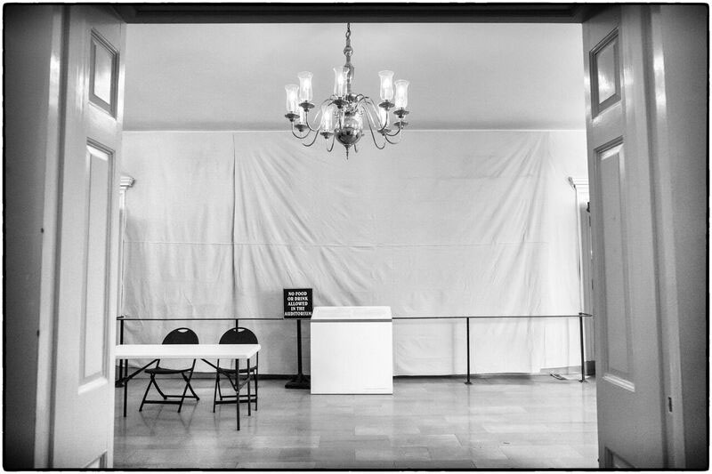
In the interim, we will shroud the painting from view and provide an on-site explanation for why we have taken this action. Ironically, a wall designed to welcome and educate is for so many the embodiment of a social and cultural wound that remains to this day. The first step must be to alleviate the pain by bandaging the wound. Then, we turn our attention to healing. As in all things we do, we will use this situation as a learning opportunity that promotes openness, compassion, and an appreciation of our diverse past and present.
Covered mural, 2015

25. In January, 2016, the President appointed the Memorial Hall Art Committee (“Committee”) of faculty, staff, a student, and a community representative to recommend a long-term,comprehensive plan to provide context and consideration for the mural and its presence for the University community which would further the educational and artistic purposes of the O’Hanlon Mural. The Committee, which still exists, is co-chaired by Terry Allen, the Associate Vice President for Institutional Equity, and Stuart Horodner, the Director of the University Art Museum.
26. In a campus-wide communication on September 2, 2016, via his blog on UKNow, the President announced that the O’Hanlon Mural would not be removed and would be uncovered once explanatory panels, new curricula for instructors choosing to use the space, and companion art could be prepared and installed.
27. By March, 2017, the O’Hanlon was ready for its second unveiling. This took place in a ceremony held in conjunction with the 22nd Annual African American and Africana Studies Black Women’s Conference. The interim director of the AAAS stated in the announcement for the event that, “[a]s we unveil the mural, it is important that we honor the recommendation of the Presidential committee that we present the artwork in context and alongside opportunities for the UK community to express their thoughts on it.”
28. The O’Hanlon Mural remained uncovered until April, 2020.
29. On July 12, 2017, the Committee implemented its recommendation with the approval of the President, who acted without the approval of the Board of Trustees, to grant a commission to an artist to create a companion piece with the O’Hanlon Mural to be installed at Memorial Hall. The Commission’s call to artists for works set a deadline September 1, 2017, with a $30,000 budget, and described the guidelines for judging the proposals as:
‘The possibility of contemporary art helping to reshape the experience of Memorial Hall and the O’Hanlon mural is very exciting. We are committed to a thoughtful process of solicitation and selection, and a result that engages our campus and community in active learning and shared values,’ said Committee Co-Chairs Terry Allen and Stuart Horodner.
In commissioning these new artworks, the committee seeks to re-imagine the challenge taken up by O'Hanlon in 1934: to depict Kentucky's evolution from a frontier state to a modern Commonwealth. Contemporary artists are invited to interpret the complex realities of Kentucky and the United States today.
The committee seeks works which will:
- engage issues of history, race, identity, culture and diversity;
- exemplify a strong concept and skillful use of materials; and
- contribute to an inclusive educational environment.

30. In March, 2018, the Committee announced the two finalists for the Memorial Hall commission, both nationally known, prominent Black women artists: Karyn Olivier (“Olivier”) and Bethany Collins (“Collins”). In announcing the finalists, Co-Chair Horodner stated, “[n]o single artwork will address all of the ideas and emotions that people have about the mural at Memorial Hall. What we want is a thoughtful new work that can expand the conversation about the legacies of Kentucky and the United States, and for something commissioned in 2018 to address the complexities of identity and place in the past as well as the present.”
31. On March 20 and 29, 2018, Oliver and Collins presented their proposals to the Committee, met with the President and some of the students who took part in the initial meeting with the President in November, 2015, and toured the campus.
32. On June 22, 2018, during the President’s Report portion of the Board of Trustees meeting, the President and Co-Chair Allen announced that Olivier had won the commission for her proposed installation at Memorial Hall. The finalization of the commission only required the approval of the full Committee. In providing a detailed description of the process followed by the Committee and its decision to award the commission to Olivier, Allen stated, “[the] Committee was overwhelmingly supportive of Karyn Olivier’s proposal and feel it will provide greater context to Memorial Hall for many years to come, and more importantly, it continues the conversation.”
33. The Board of Trustees took no action on this report of the President, and did not approve or otherwise take any action on the contract with Olivier for the installation of her proposal. As of the time of the filing of this action, upon information and belief based on a full review of the published minutes and agendas of the Board of Trustees from 2015 through June, 2020, the Board of Trustees has taken no formal action to approve of any actions taken by the President concerning the O’Hanlon Mural or the Olivier Installation.
34. The Olivier installation sought to specifically engage the O’Hanlon Mural :
There are eight sections in the mural that contain African-American and Native American figures — a horse carriage driver, a figure in a tree, musicians providing entertainment, four central figures planting, three in the top right corner working the land, two sitting near a pond, several at the train station, and the lone Native American represented in the mural, emerging from a forest. My response to this is as follows: The dome in the vestibule will be gold leafed and will contain images of these ‘displaced’ figures as they are represented in the original mural. The insertion of the figures on the gilded ceiling reinforces the notion or possibility of rebirth — perhaps spiritually, but more importantly through the viewer’s reinvestigation, interrogation and reckoning with our country’s complex histories. Around the base of the dome will read the Frederick Douglass quote, ‘There is not a man beneath the canopy of heaven, that does not know that slavery is wrong for him.’
I hope one reading of my use of gold leaf within my artwork will serve to elevate the oppressed represented — those who were deemed lowly — to the divine. The imagery in the mural depicts the subjugated performing mundane chores and activities while neglecting to reveal the servitude and range of horrific acts that kept them there.
Portraits of important figures in Kentucky's history will be placed near the building's dome. They include: Chief Red Bird, a Cherokee who lived among white settlers in Clay County until his murder by two Tennessee men. Charlotte Dupuy who was an enslaved African-American woman who filed a freedom suit in 1829 against her master, Henry Clay, then the country’s Secretary of State. Peter Durrett, a preacher who founded First African Baptist Church in Lexington, Kentucky, in 1790. Georgia Davis Powers, the first African American to serve in the Kentucky Senate, sponsoring bills prohibiting employment discrimination, sex and age discrimination.
My intent in adding these portraits is not just to honor these Kentucky heroes and illuminate what history has left shrouded — but that by elevating these figures, their overlooked legacies will shine the light of truth on the racist caricatures that were acceptable ‘histories’ in the original mural.
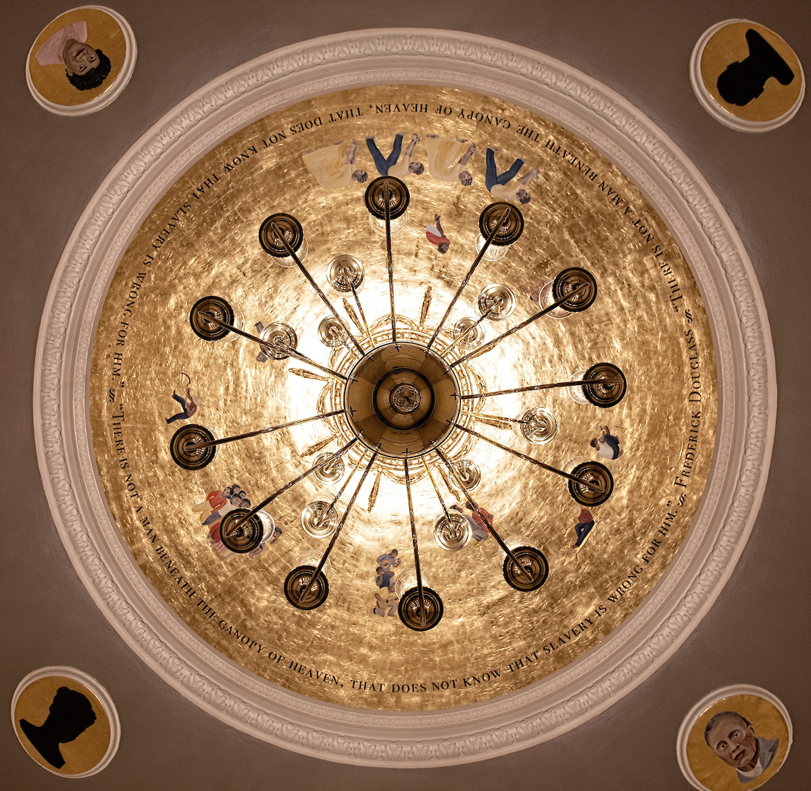
Witness, September, 2019
35. In late August 2019, the Olivier installation titled Witness was unveiled and remains in place at Memorial Hall.
36. As part of the adopted recommendations of the Committee, the University no longer holds required classes at Memorial Hall. Various professors including poet and faculty member Frank X. Walker and writer and faculty member Erik Reece, as well as others, have used the art and explanatory features in their courses. Other groups have also used Memorial Hall. In every instance, materials developed by the Committee have been provided to instructors, faculty members, and groups using Memorial Hall to guide the use of the space.
37. Based on the installation of the Olivier work, the termination of regular classes at memorial Hall, the placement of explanatory panels, and the first steps in using the space to address the issues triggered by the O’Hanlon Mural that led to the student meeting with the President in December, 2015 at Maxwell House, the Committee, though not formally terminated, ceased to regularly meet and awaited further action items from the President or the Board of Trustees.
38. On March 31, 2020, the President met with a coalition of students from the Black Students Advisory Council and the Basic Needs Campaign. Amongst their demands was the removal of the O’Hanlon Mural, which the President declined to do citing the work of the Committee and that the Mural could not be removed without risking its destruction. The President agreed to “re-engage with a new committee to determine a long-term plan”.
39. In response to this announcement, Olivier published an Open Letter to the University community, and specifically students of color, in the student newspaper the Kentucky Kernel. Amongst her points:
We must dissect and critique our American histories, shed light on what’s hidden/buried, and expose this complicated landscape for all to investigate and interrogate. Our complex histories need to be wrestled with, even when they can’t be resolved. How do we reconcile dissent, multiplicity, simultaneity and paradox, which are imbedded in our country’s history? Erasing (or removal), we know, does not erase the historical facts of slavery and oppression.
* * * *
But O’Hanlon’s mural cannot be equated with them; she was charged with creating a historical painting, and black people (mostly subjugated) were a part of Kentucky’s history. Certain aesthetic and conceptual decisions reveal (what I believe to be) her acknowledgment (albeit possibly a superficial one) that America—and Kentucky specifically—was built by African-Americans. Artists are intentional in their decisions—she positioned the four slaves in the center of the mural; those figures are the linchpin. Kentucky, she recognizes, was built on their backs. She portrays the symbolism of industrialization—the railroad—literally on the backs of the slaves. I know I’d rather see an acknowledgment of slavery (notwithstanding the sanitized way it is portrayed here), then no acknowledgment at all. I get it. Why can’t we see black folks not suffering? Can we just see black characters living ordinary complex lives that white folks get to see? Not just as victims? But witnessing the portrayal of our ancestors’ narratives is necessary in understanding and living in contemporary America. Our country, as we know, is in perpetual irresolution.
* * * *
If the art is removed, doesn’t it just give folks an out? An excuse not to remember painful realities? Historical amnesia? And negate the need for our continued fight?

40. On June 5, 2020, the President sent a written announcement to the University community via UKNow in which he announced that “ . . . I am directing our facilities team to immediately begin the process of removing the mural in Memorial Hall.”
41. Neither in this communication nor any public comment has the President amplified on this announcement. Despite acknowledging the high risk of destruction to the unique, priceless work of public art that is literally intrinsic to the building and the property of the people of Kentucky, he gives no information whether an attempt will be made to move it, who will perform such a task, and what the cost will be to the taxpayers of Kentucky if such an attempt is made.
42. A review of the meetings of the Board of Trustees from March through July, 2020, indicate that this proposed action of removing the O’Hanlon Mural has not been discussed in a President Report nor any authority sought to carry out the proposed plan of removal.
43. Neither is there any evidence that either the Committee or the proposed new committee promised at the March 31, 2020, was consulted by the President or has even met.
44. On July 1, 2020, the National Coalition Against Censorship, a non-profit organization whose mission is to promote freedom of thought, inquiry and expression and oppose censorship in all its forms wrote to the President expressing serious concerns “that the University of Kentucky recently reversed course and decided to remove a WPA-era mural by Ann Rice O’Hanlon depicting a history of Kentucky that many believed sanitized the portrayal of slavery and presented stereotypes and caricatures of people of color. In doing so, the University has effectively negated a contemporary work by a Black artist that it specifically commissioned in 2018 to, in your words, set up ‘a dialogue between the two pieces of art.’” The NCAC urged the President to reverse the decision to protect both the O’Hanlon Mural and the Olivier Installation, which is dependent upon the Mural for her artistic expression.
45. The President has not responded to the NCAC’s letter.
46. Prior to announcing the decision on June 5, 2020 to remove the O’Hanlon Mural, and negate the artistic meaning of the Olivier Installation, the President did not discuss or warn or otherwise communicate with Olivier. Instead, she learned of the decision via press reports.
47. Based upon the public announcement of the President made unilaterally without any approval or authority by the Board of Trustees and without consulting the Committee, Kentucky State government, the federal government or any other person or entity or agency who may have a legal interest in this matter, the O’Hanlon Mural is at immediate risk of being removed and destroyed and the Olivier Installation either removed and destroyed or otherwise rendered meaningless.
Claims for Relief
1. Declaration of Rights
48. Pursuant to KRS 418.040, the Berrys seek a declaration of whether their rights are impaired by the removal or destruction of the O’Hanlon Mural.
49. The O’Hanlon Mural came into being as a result of public monies spent pursuant to a federal law enacted for the charitable and public purpose of promoting a governmental purpose and the advancement of knowledge and education.
50. These monies were provided to Ann Rice O’Hanlon and the University by the federal government to create the O’Hanlon Mural.
51. The resulting work of public art is publicly owned by virtue of a limited title vested in the Commonwealth for the use and purposes of the University.
52. The work of art is thus held in charitable trust for the benefit of the public to further the charitable purposes for which the gift of funds to the Commonwealth was given to the Commonwealth and the University by the federal government.
53. The announcement by the President that the O’Hanlon Mural will be removed and taken down defeats the charitable purpose for which the public art work was created and funded, and thus establishes that an actual controversy exists between the Berrys and the Defendants.
54. The Berrys both as members of the general public and as persons with a special interest in the enforcement of the terms of this charitable trust by virtue of their familial relationship to O’Hanlon have legal standing and the right to petition for an order compelling the University to maintain in situ the O’Hanlon Mural.
55. For these reasons, the Berrys seek a declaration of rights and an order directing that the University and the President maintain the O’Hanlon Mural in situ.
2. Permanent and Temporary Injunction
56. Pursuant to CR 65.01 and 65.04, the Berrys seek both temporary and permanent injunctive relief.
57. Based upon the statement of the President that the O’Hanlon Mural will be removed and that the Olivier Installation may either be removed or left void of any artistic meaning, the rights of the Berrys will be violated pending a final judgment in this action.
58. Pursuant to KRS 164A.575(8) only the Board of Trustees has the power to “sell or otherwise dispose of all real or personal property of the institution which is not needed or has become unsuitable for public use . . . as determined by the Board.”
59. The actions and proposed action of the President with respect to the O’Hanlon Mural and the Olivier Installation are ultra vires and beyond the scope of the power of the President.
60. Regardless of whether the Board retroactively approves the proposal of the President to act as proposed with respect to the O’Hanlon Mural and Olivier Installation, such action is contrary to the requirements of the federal government in protecting its interest in the O’Hanlon Mural and thus the terms of the commission entered into with Olivier.
61. For these reasons, the Court should grant both temporary and permanent injunctive relief.
WHEREFORE, for the foregoing reasons, the Berrys respectfully demand to recover as follows:
1. An order declaring their rights in the O’Hanlon Mural, that the proposed removal of the O’Hanlon Mural is contrary to law and a further order preventing the Defendants from removing the O’Hanlon Mural or the Olivier Installation;
2. Temporary and Permanent Injunctive relief precluding the Defendants from removing the O’Hanlon Mural or the Olivier Installation;
3. Taxable costs and attorney fees; and,
4. Any other relief the Court deems just and proper.

This the 6th day of July, 2020

__________________________________
Scott White
Carman Fullerton, PLLC
111 Church Street
Lexington, KY. 40507
859.971-0060
swhite@carmanfullerton.com

___________________________________
Jessica Winters
The Winters Law Group, LLC
432 S Broadway Suite 2B
Lexington, KY 40508
859.309-4659
jessica@thewinterslawgroup.com

